save matchedash bay

Table of Contents
Authors 2
Acknowledgments 2
Summary 2
About Matchedash Bay 2
Project Team 3
Introduction to Phragmites 3
What is Phragmites? 4
Identification – Native vs. Invasive 4
Hybridization 4
DNA Sampling 5
Species at Risk (SARs) 6
Overview 6
Highlights 6
Challenges Faced 7
Maps and Tables 7
Methodologies 8
Phragmites Control 8
Community Involvement 9
2022 Outlook 10
Appendices 10

Authors
This report was prepared 2021 by Georgian Bay Forever
- Nicole Carpenter, Project Coordinator

Acknowledgments
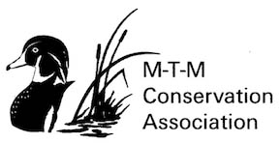
Funding and assistance for the 2021 Save Matchedash Bay project was provided by Ganawenim Meshkiki (GMI) who is the Trustee of the Eastern Georgian Bay Initiative (“EGBI”) managed by Henvey Inlet First Nations, Habitat Stewardship Protection (HSP) through Environment and Climate Change Canada (ECCC), MTM Conservation Association and our many individual donors. We send our sincerest thanks to all for the investment in this initiative.

Summary
2021 marks the start of a 2-year project to Save Matchedash Bay. GBF has partnered with Ganawenim Meshkiki, the MTM Conservation Association and the Severn Sound Environmental Association (SSEA) to remove invasive Phragmites, monitor species at risk in the wetland and advance knowledge of the risk of Phragmites to biodiversity in Matchedash Bay. Georgian Bay Forever (GBF) has been working with invasive Phragmites along the Eastern shorelines of Georgian Bay, Lake Huron for the past 9 years.

About Matchedash Bay
Matchedash Bay is located within Simcoe County in Central Ontario, Canada. In 1996, Matchedash Bay Provincial Wildlife Area was designated a Ramsar Site, defining it as a Wetland of International Importance for the conservation and wise use of wetlands and their resources (https://www.ramsar.org). It is one of 2,433 wetlands across the globe that cover a total of approximately 255 million hectares. The water levels are constantly fluctuating in the day due to the North River and Coldwater River tributaries and the greater Georgian Bay, Lake Huron waterbody. It is home to over 170 species of birds, 568 plant species and many fish, reptiles, amphibians and mammals. This wetland is composed of a variety of habitats including swamps, cattail marshes, beaver ponds, hardwood forest, agricultural lands, native grass meadows and a coniferous wetland forest.
Various recreational activities such as canoeing, kayaking, boating, fishing, hunting, birding and hiking are all popular in and around Matchedash Bay. The wetland is also subject to development of cottages and marinas as well as agricultural activities in the surrounding areas putting the site at risk.
Figure 1. Map of Matchedash Bay, located in the Township of Severn.

Project Team
Nicole Carpenter was the Save Matchedash Bay Project Coordinator responsible for planning, organizing and delivering goals for the current project through outreach and coordination activities. Local summer students Sean Mullin and Jared McNabb participated in education outreach activities as well as mapping and removing Phragmites in Matchedash Bay from June to mid-September. Species at Risk monitoring was conducted by the Severn Sound Environmental Association of which the primary investigators were Michelle Hudolin (SSEA Wetlands & Habitat Biologist), and contractor Robert (Bob) Bowles. Additional SSEA staff and volunteers assisted with field investigations, including Nicole Stott (SSEA Biodiversity Conservation Intern), Tamara Brincat (SSEA Invasive Species Program Coordinator), Ben Lehan (SSEA Environmental Intern), and Grant Hudolin (volunteer). Naturalists and local community members provided SSEA with very helpful information about past species observations in the study area.

Introduction to Phragmites

What is Phragmites?
Some of the most pristine coastal wetlands are found in Georgian Bay, Lake Huron. Many organisms depend on these wetlands for life-sustaining activities such as foraging, spawning, shelter and more. Invasive species are non-native plants or animals that have been introduced to an ecosystem and have the ability to spread and disrupt the native wildlife. They are a threat to the environment and the broader economy.
Non-native Phragmites are a significant threat to the Great Lakes along with many other invasive species. We acknowledge that invasive Phragmites is a reed grass that unwilfully travelled from Europe to Canada in the 1800s through human activity and has developed as a significant threat to Georgian Bay’s coastal wetlands. Phragmites can be divided up into 2 lineages. The native subspecies, Phragmites australis americanus, and the invasive subspecies, Phragmites australis australis, which are both found in Matchedash Bay.
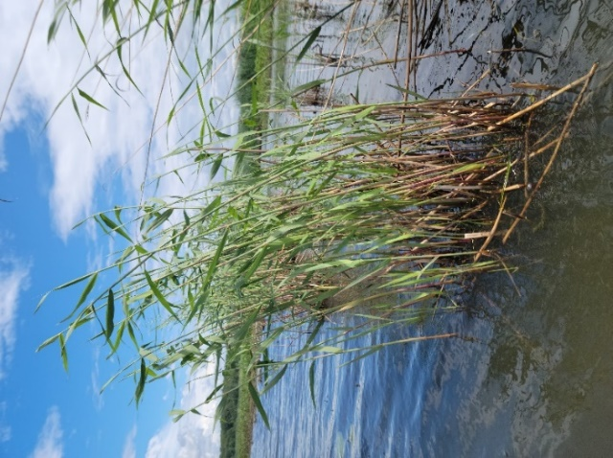
In its natural environment, Phragmites does not pose any threat to other organisms and encounters 140 fellow creatures that live in balance with each other. Living in North America, the invasive lineage does not have any natural threats or predators which allows it to flourish in an unbalanced way by poisoning our native species that have not evolved to live in harmony with it. Unfortunately, in the Great Lakes coastal ecosystems, invasive Phragmites grows quickly into extremely dense monocultures, outcompeting native vegetation and reducing biodiversity and habitat for native plants and animals. Furthermore, this impairs proper functioning of wetlands which are significant ecosystems that enhance water quality, provide shelter and food for other relatives and sequester carbon helping to counter human caused Global Heating.

Identification – Native vs. Invasive
Figure 2. Native Phragmites in Matchedash Bay.

Invasive Phragmites can be identified by their connecting root system of hollow rhizomes, beige stems and tall green stalks with alternating leaves. The stalks, if well-established, can grow up to 15 ft tall. Native Phragmites looks quite similar but does not grow as tall or dense and will co-exist amongst other native species. In late August and into the fall, invasive phragmites begin to develop large purple/reddish seed heads, unlike the native Phragmites that develop seeds earlier in the season. After seeds disperse in the fall, the stalks die and remain standing throughout the winter strong and dry posing as a fire hazard. Majority of native plants will fall under the weight of snow, break down, contribute nutrients back to the soil and allow space for new vegetation to grow come Spring. The remains of dried out stalks of invasive Phragmites prevent new growth of native plants in the Spring. During the summer, one can identify a stand of invasive phragmites by the presence of leftover standing stalks and seeds from years previous. Phragmites Identification Tips | Georgian Bay Forever
Figure 3. Invasive Phragmites in Matchedash Bay.

Hybridization
More often than not, identifying the native vs. invasive lineage can be quite difficult and may require DNA sampling to be done. Recently, there have been cases in Ontario, CA and Michigan, USA where individuals have described these “difficult to identify” stands as having characteristics falling under both native and invasive lineages. In the past, GBF has experienced sites on Georgian Bay that grow quite tall and dense (invasive characteristics) but have very distinct red markings on the stalk, have light coloured, sparse seeds heads and seed earlier in the season (native characteristics). In addition, these sites of uncertainty grow alongside patches of Phragmites that we can confidently say are invasive. Though rare, in the last decade there have been reports about hybridization between native and invasive Phragmites. Currently, there are no reports of hybridization in Georgian Bay.

DNA Sampling
Along the North River and Coldwater there were many sites of uncertainty found. The Phragmites in these locations were large, dense and tall like the invasive but also displayed a lighter green/yellow colour, red stalks and sparse seed heads similar to the native strain. In discussions with SSEA and MTM Conservation Association, there was still uncertainty in the identification of these sites. In the fall, GBF’s Project Coordinator collected 7 samples and sent them to the Wendell Lab at Oakland University for analysis (https://doi.org/10.1016/j.jglr.2021.08.002).

Figure 4. Collecting DNA Sample 5 along the North River.

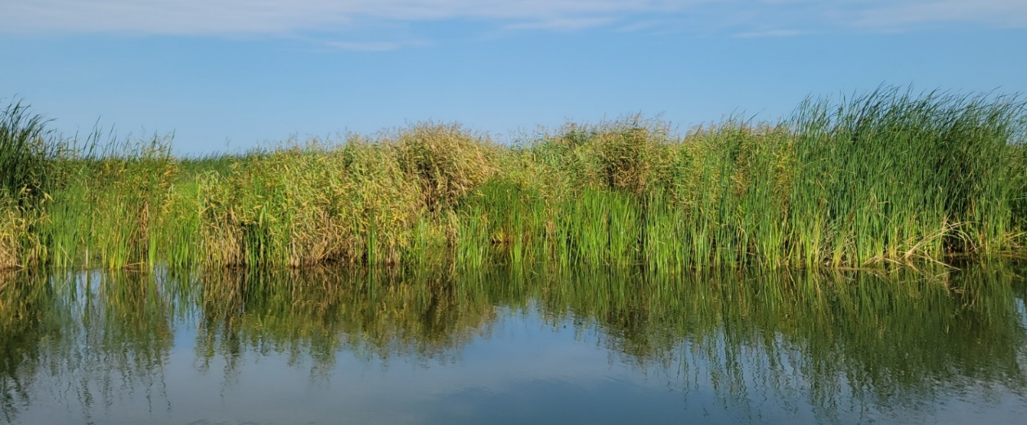

Figure 5. Native Phragmites and cattails on the Coldwater River. Sample 6 of DNA collection.

DNA Results
Of the sites of uncertainty sampled, 6 out of 7 were identified as native, with only 1 as invasive alongside a busy road on the outer corridor of the wetland. There were no hybrids identified. With these results, we are able to better plan for the 2022 season, knowing which sites to cut and which to leave. With 3 sites in the main proper, 7 in the North River and 18 along the Coldwater River, Matchedash Bay is home to 28 native Phragmites stands that appear to be growing quite strong.
Table 1. Location data collected of DNA Samples 1-7.
Sample | Location | Latitude | Longitude | Questioned Lineage | Results (Invasive, Native, Hybrid)
1 | Quarry Road | 44.774822 | -79.653392 | Invasive | Invasive
2 | Lawson Ln | 44.744139 | -79.639822 | Hybrid | Native
3 | Lawson Ln | 44.744139 | -79.639822 | Hybrid | Native
4 | Lawson Ln Parking Lot | 44.7840004 | -79.635835 | Invasive/Hybrid | Native
5 | North River | 44.739316 | -79.639051 | Hybrid/Native | Native
6 | Coldwater River | 44.728993 | -79.651736 | Hybrid | Native
7 | Coldwater River | 44.732001 | -79.652344 | Hybrid | Native

Species at Risk (SARs)
The establishment of invasive Phragmites has a potential to affect a variety of habitats and species such as those at risk. Its ability to outcompete native vegetation and grow extremely tall and dense threatens these species at risk even more by impeding on their ability to survive. The current project involved species at risk monitoring conducted by the Severn Sound Environmental Association and volunteers. Field investigations took place in spring, summer and fall of 2021 to document the species of concern within various habitats in the study area. Field work involved visual encounter surveys using binoculars and spotting scopes from a canoe and/or various locations amongst the wetland. No mark and re-capture activities were conducted. Provincial Survey protocols for species at risk in Ontario were followed (MNRF, 2015). SSEA staff and volunteers monitored Matchedash Bay for a total of 23 field days. We hope to continue this monitoring in 2022.
Information about species at risk and their locations is quite sensitive and not intended for public disclosure, thus will not be discussed in this report. If you have any questions, concerns or comments, please contact Nicole.carpenter@gbf.org.

Overview

Highlights
- 44 invasive Phragmites sites found in Matchedash Bay
- 18 sites cut, or 40% control in the first season. There are no sites in the eradicated/monitoring stage yet because it is the first year of control, but we hope to see a decrease in growth in 2022.
- 26 sites were left untreated
- 28 native Phragmites sites found

Challenges Faced
This being the first year into Matchedash Bay, GBF was bound to face some challenges tackling invasive Phragmites. Due to the inaccessibility of sites and uncertainty when identifying sites as native or invasive, GBF was not able to cut each site as we had hoped. Many of the sites are located amongst vast stretches of cattail marshes that are too dense for a boat to reach, and water too deep for staff to walk to. Some sites were only accessible by canoe travel through beaver paths. GBF has purchased a canoe for next season to be utilized to get to these hard to reach locations in 2022. In addition, GBF hopes to plan some winter cuts in the wetland once the ground safely freezes over. This is not something done often but has been shown to help decrease the density of stands. This can help make it easier when cutting the summer as well as open up space for any native vegetation that may be trying to grow.
As mentioned in the Introduction to Phragmites section of this report, there was a lot of discrepancy when it came to identifying the native vs. invasive Phragmites. Because of this, many of the stands along the Coldwater River and North River were not treated. Fortunately, majority of these stands turned out to be native.
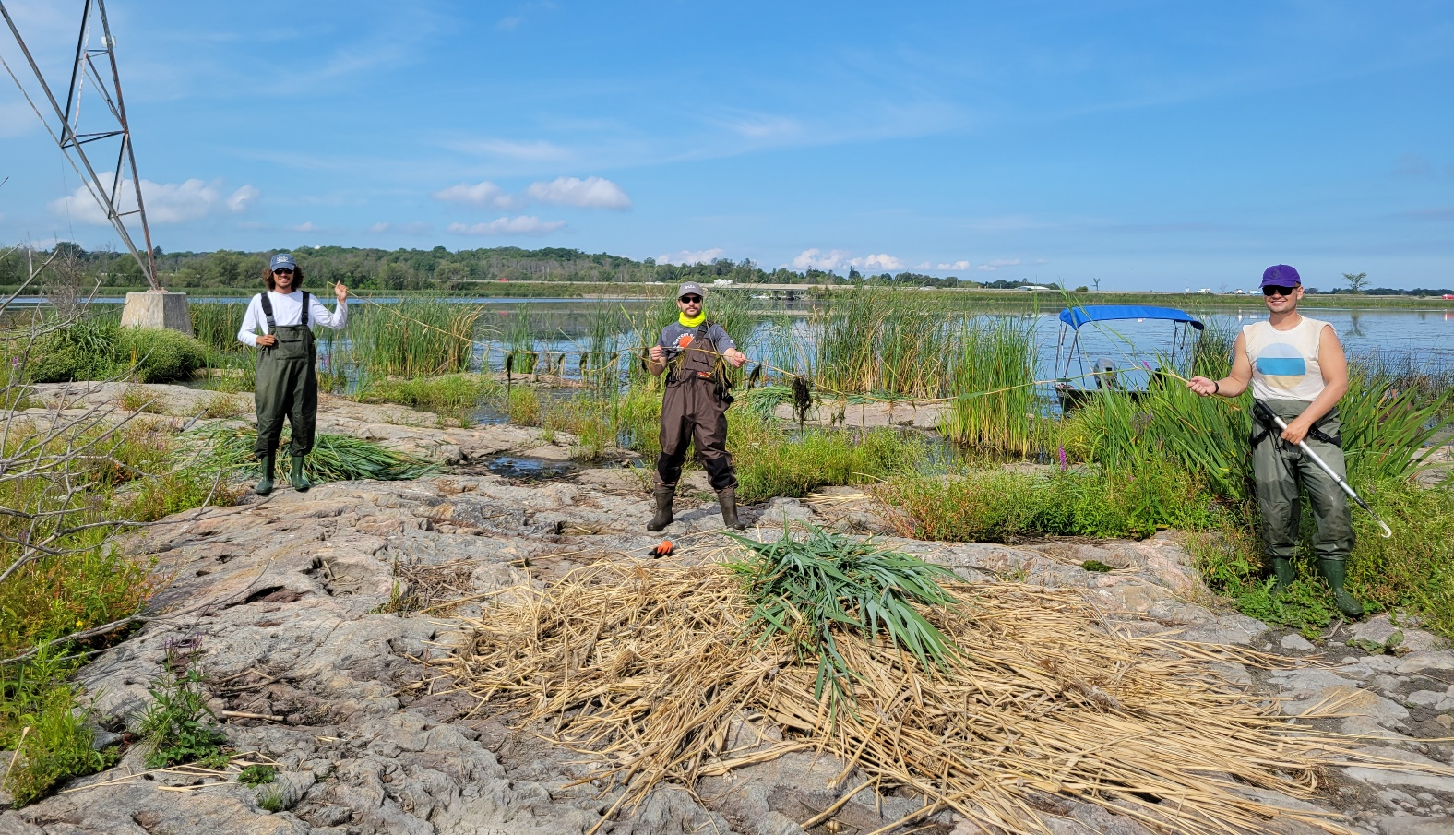
Figure 6. GBF and SSEA holding an extremely long Phragmites rhizome.

Maps and Tables
Table 2. Breakdown of all Phragmites sites in Matchedash Bay.
Figure 7. Map of all stands in Matchedash Bay. Yellow represents invasive sites cut, red represents invasive sites untreated and blue represents native sites.

 | Total sites | New Sites | # of sites Eradicated/  Monitored | # of sites Cut | # of sites Controlled (Eradicated/  Monitored + Cut) | # of sites Untreated | % Eradicated/  Monitored | % Cut
Matchedash Bay | 44 | 41 | 0 | 18 | 18 | 26 | 0% | 41%

Methodologies

Phragmites Control
Each year GBF maps the eastern shoreline of Georgian Bay in June recording the location, size, density and status of both recurring sites (from years previous) and new sites found. GBF continues to return to sites that have been mapped and cut in previous years in hopes not to see any regrowth. In this case, the stand is put into the monitoring/eradicated category and remains to be checked for years to come. GBF has been working with invasive Phragmites along the Eastern shorelines of Georgian Bay, Lake Huron for the past 9 years. GBF utilizes the control methods and techniques outlined in Ontario’s Invasive Phragmites Best Management Practices (2020).
- Location Mapping: Using a mapping software (i.e. Google Maps), GBF identified the locations in which native and invasive Phragmites was present in Matchedash Bay and its surrounding wetlands, ponds and tributaries. Geographic coordinates, size, density and other notes are recorded to help develop a management plan.
- Timing: Cutting takes place during the primary growth stage of Phragmites which is around Mid-July to mid-August before seed heads emerge. This has been found to have the strongest impact on minimizing regrowth.
- Equipment: Raspberry cane cutters and long-reach hedge trimmers are used to cut the Phragmites below the water surface and as close to the bottom as possible. Natural twine is used to bundle the cut biomass for easy transport and disposal. In addition, basic safety equipment such as gloves, ear protection, sunscreen and chest waders are all used. GBF uses a canoe and a 16ft Smokercraft motorboat to navigate in Matchedash Bay.
- Prioritize: Priority is given to small stands first to ensure early eradication before the stand gets large and dense. It often takes a few years of cutting to completely get rid of a stand of Phragmites therefore we give priority to stands that have been cut previously. Each year, the stand should get smaller, more sparse, and easier to tackle. Large, dense sites are cut next with a big team (i.e., volunteers) to be most efficient.
- Selective Cutting: Only invasive Phragmites stalks are removed, leaving native vegetation unharmed. If there are seed heads, they are removed from the stalks and placed into paper yard waste bags to dry out.
  - Cut to drown method: Each stalk is cut under water as close to the sediment as possible, allowing water to drown out the hollow root system.
- Clean-up: To clean-up, GBF bundles the cut biomass and makes sure no pieces are left behind, specifically the roots as they can fragment and grow new shoots.
- Disposal: A designated spot is determined near the removal location where the cut stalks can dry and decay. It is far enough from the waters edge that rising water levels and storm waves will not pull the biomass back into the water. The site will be checked every year to ensure there is no growth at the disposal site.
- Follow-up: Phragmites is a perennial reed grass meaning it will grow back every year. If left untreated, it will grow back larger and more dense. If treated (i.e., cut), the stand will grow back smaller and sparse, until eventually there is no regrowth. This can take 2-5 years of cutting activities depending on the size of the stand. Eventually native plants will return, and the habitat will be restored.
For more information or training on how to remove invasive Phragmites from shorelines in Matchedash Bay, contact Nicole.carpenter@gbf.org.
If you are interested in volunteering and becoming a Phragbuster, contact Nicole.carpenter@gbf.org

Community Involvement
Events
Coldwater Mill Farmers Market
Project Coordinator, Nicole Carpenter, and summer Phragbusters, Sean, Jared, Adam and David, attended a variety of farmers markets across the eastern Georgian Bay coast to spread knowledge and awareness of the threat invasive Phragmites has to coastal wetlands including Matchedash Bay. Most local to Matchedash Bay was the Coldwater Mill Farmer’s Market that GBF attended to handout educational material and answer questions for the community about our new work removing invasive Phragmites and monitoring species at risk.
Community Cuts
GBF hosted 2 community cuts with help from SSEA and MTM Conservation Association in different areas of Matchedash Bay. Volunteers dedicated a total of 30 hours to invasive phragmites removal from the main proper and Beaver Pond over the summer.
Figure 8. GBF and MTM Community cut at the North Beaver Pond (aka Quarry Rd Pond).

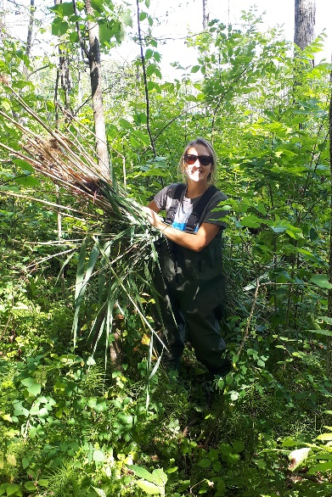
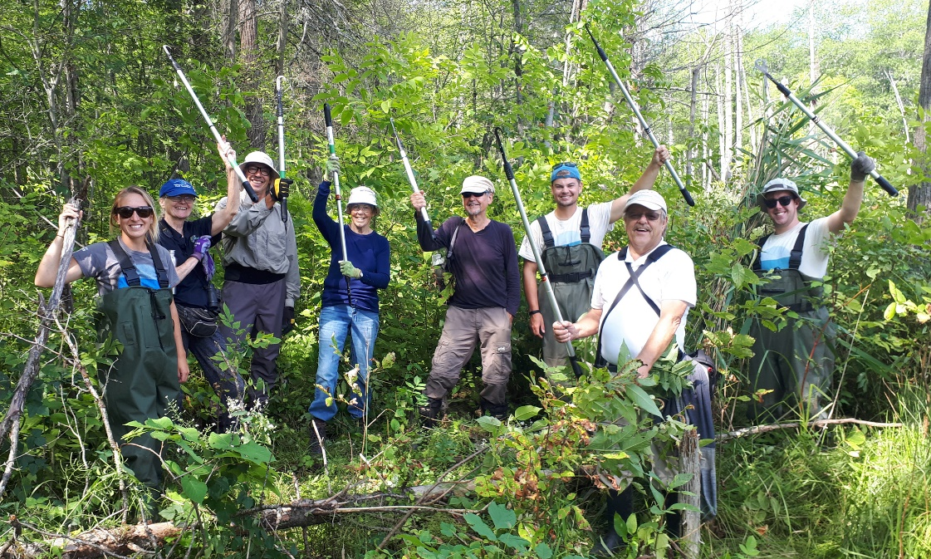
2022 Outlook
Looking into 2022, GBF will continue to monitor and manage invasive Phragmites in Matchedash Bay. In June, it will be mapped again, and a priority plan will be developed. Any small sites mapped will be cut first along with any sites that were cut in 2021 to work toward eradication. GBF will continue to educate the community and recruit volunteers for Phragmites removal. In 2022, GBF expects to increase the amount of control in Matchedash Bay with the purchase of a canoe and hiring 2 summer staff to be dedicated to cutting in Matchedash all summer long. In addition, GBF looks forward to continuing work with MTM Conservation Association and SSEA for further Phragmites efforts and species at risk monitoring.

Appendices
Appendix A. Table of all 72 Phragmites sites, native and invasive.
Site ID | Latitude | Longitude | New Site (Y or N) | Size | Density | Status | Lineage (Native or Invasive)
1 | 44.73796 | -79.6453 | y | 3 m² | M | Native | Native
2 | 44.73918 | -79.6405 | y | 4 stalks | S | Native | Native
3 | 44.73932 | -79.6401 | y | 8 m² | M | Native | Native
4 | 44.73931 | -79.6391 | y | >10 m² | D | Native | Native
5 | 44.73539 | -79.6513 | y | 2 m² | S | Native | Native
6 | 44.73545 | -79.6509 | y | 2 m² | D | Native | Native
7 | 44.75044 | -79.6789 | y | 7 m² | M | Cut | Invasive
8 | 44.75208 | -79.6885 | y | 4 m² | S | Cut | Invasive
9 | 44.7519 | -79.6883 | y | 20 m² | S | Cut | Invasive
10 | 44.75159 | -79.6881 | y | 3 stalks | S | Untreated | Invasive
11 | 44.751 | -79.6891 | y | >10 m² | D | Untreated | Invasive
12 | 44.76885 | -79.6851 | y | 15 m² | M | Untreated | Invasive
13 | 44.76887 | -79.6846 | y | 5 m² | M | Untreated | Invasive
14 | 44.74137 | -79.6578 | y | Polygon | M | Native | Native
15 | 44.75349 | -79.6963 | y | 6 stalks | S | Untreated | Invasive
16 | 44.75305 | -79.6908 | y | 3 m² | M | Untreated | Invasive
17 | 44.75513 | -79.6948 | y | N/A | D | Untreated | Invasive
18 | 44.75294 | -79.6871 | y | 8 m² | M | Cut | Invasive
19 | 44.73439 | -79.6511 | y | 7 m² | D | Native | Native
20 | 44.734 | -79.6511 | y | 30 m² | D | Native | Native
21 | 44.73355 | -79.651 | y | 30 m² | D | Native | Native
22 | 44.73298 | -79.6511 | y | 15 m² | M | Native | Native
23 | 44.73288 | -79.6517 | y | 18 m² | D | Native | Native
24 | 44.73264 | -79.6519 | y | 10 m² | M | Native | Native
25 | 44.73246 | -79.6517 | y | 1 stalk | S | Native | Native
26 | 44.73196 | -79.6523 | y | >100 m² | D | Native | Native
27 | 44.73138 | -79.6522 | y | >100 m² | D | Native | Native
28 | 44.73086 | -79.6526 | y | 3 m² | D | Native | Native
29 | 44.7309 | -79.6517 | y | 12 m² | D | Native | Native
30 | 44.73034 | -79.6515 | y | 35 m² | D | Native | Native
31 | 44.73002 | -79.6514 | y | 20 m² | D | Native | Native
32 | 44.72975 | -79.6514 | y | 30 m² | M | Native | Native
33 | 44.72886 | -79.6522 | y | 20 m² | M | Native | Native
34 | 44.7286 | -79.6518 | y | 5 m² | M | Native | Native
35 | 44.72827 | -79.6516 | y | 8 Stalks | S | Native | Native
36 | 44.72474 | -79.6503 | y | 8 m² | S | Untreated | Invasive
37 | 44.75809 | -79.6904 | y | 1 m² | S | Cut | Invasive
38 | 44.75822 | -79.6904 | y | 2 m² | M | Cut | Invasive
39 | 44.75826 | -79.6903 | y | 1 m² | M | Cut | Invasive
40 | 44.7588 | -79.6936 | y | 4 stalks | S | Native | Native
41 | 44.75872 | -79.6936 | y | 5 m² | S | Native | Native
42 | 44.76026 | -79.6908 | y | 5 m² | D | Cut | Invasive
43 | 44.75923 | -79.6901 | y | 15 m² | M | Cut | Invasive
44 | 44.7583 | -79.6989 | y | 40 m² | D | Untreated | Invasive
45 | 44.75681 | -79.6939 | y | 15 m² | D | Cut | Invasive
46 | 44.75686 | -79.6938 | y | 2 m² | M | Cut | Invasive
47 | 44.75675 | -79.6935 | y | 30 m² | D | Untreated | Invasive
48 | 44.75473 | -79.6728 | y | 12 stalks | S | Untreated | Invasive
49 | 44.75494 | -79.6726 | y | 2 m² | M | Untreated | Invasive
50 | 44.75413 | -79.672 | y | 2 m² | M | Untreated | Invasive
51 | 44.75389 | -79.6712 | y | Polygon |  | Untreated | Invasive
52 | 44.75012 | -79.6683 | y | 6 stalks | S | Untreated | Invasive
53 | 44.74943 | -79.668 | y | 3 stalks | S | Untreated | Invasive
54 | 44.74852 | -79.6681 | y | 12 m² | D | Untreated | Invasive
55 | 44.75813 | -79.6815 | y | 12 stalks | M | Cut | Invasive
56 | 44.75815 | -79.6992 | N | 25 m² | D | Untreated | Invasive
57 | 44.75913 | -79.6969 | N | 15 m² | D | Untreated | Invasive
58 | 44.75916 | -79.6964 | N | 5 m² | M | Untreated | Invasive
59 | 44.75852 | -79.6924 | y | 2 m² | M | Untreated | Invasive
60 | 44.75697 | -79.6938 | y | 3 m² | D | Cut | Invasive
61 | 44.75695 | -79.6938 | y | 5 m² | S | Cut | Invasive
62 | 44.75688 | -79.6937 | y | 2 m² | M | Cut | Invasive
63 | 44.77285 | -79.6734 | y | 15 m² | D | Cut | Invasive
64 | 44.77337 | -79.6736 | y | 8 m² | D | Cut | Invasive
65 | 44.77355 | -79.6738 | y | 8 m² | D | Cut | Invasive
66 | 44.77353 | -79.6691 | y | Unknown | D | Untreated | Invasive
67 | 44.7738 | -79.6693 | y | Unknown | D | Untreated | Invasive
68 | 44.71813 | -79.6511 | y | 20 m² | M | Untreated | Invasive
69 | 44.718 | -79.6551 | y | 50 m² | D | Untreated | Invasive
70 | 44.72583 | -79.6532 | y | >100 m² | D | Untreated | Invasive
71 | 44.74007 | -79.636 | y | 50 m² | D | Native | Native
72 | 44.72617 | -79.6529 | y | 50 m² | D | Native | Native

